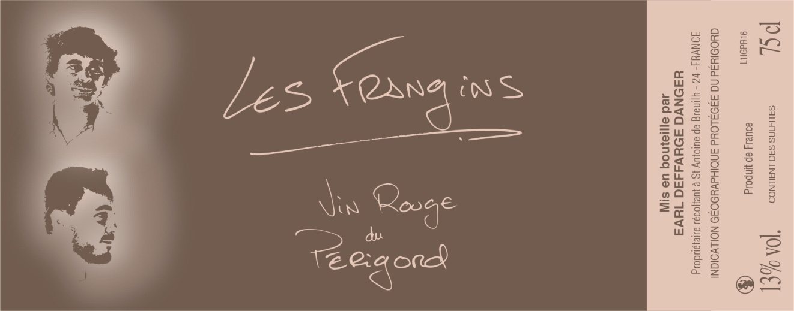
Les Frangins
IGP of Périgord Rouge

Coming from a multi centennial family property, this cuvée « Les Frangins » combines modernity and conviviality for a easy and immediate pleasure …

Grappes : Merlot 50 %, Cabernet Sauvignon 50%
Terroir : chalky and clayey soil on hill side dominating the Dordogne valley at 80 m high.. The vineyards are farmed in substainable agriculture « Terra Vitis » and recognized High Environment Value III (HVE3) certifications, no treatment on soil and air .

Vinification : Harvested at good maturity, thermo vinification , short vating 10 days in tank to keep fruty flavors. Early bottling.
Tasting : Pleasure wine. Strawberries flavours and crunchy taste.
Gastronomy : Red and white meat, Barbecue, Aperitive, Summer food.
To drink now and serve at 16 – 18 °C

